***TEAM MANAGEMENT SYSTEM***

***1.1 Problem Statement:***

*Managing a Football team manually is often difficult for the Owner or Managers. Managing a Team of different players with vivid styles is not easy. Keeping track on the team analysis and players statistics might be hectic and non-reliable on paper. It becomes quite easy to keep and maintain records on computer or website using Management System for it.*

***1.2 Project Objective:***

*Help New or Weak Teams to Grow and Compete with Big Teams and become strong. Also to help them in keeping track of team virtually and keep all records on Internet.*

***1.3 Project Scope:***

*Globally over Inernet.*

***2.1 Functionalities:***

* *Register / Login*
* *Buy Pack for Team Management*
* *Payment*
* *Team, Players, Owner, Coaches, information*
* *Practice, Friendly, Tournament/League Match Schedule*
* *Practice/Training Session Schedule*
* *Team, Individual Player Statistics*
* *Team, Individual Player Analysis/Performance*
* *Transfers, Changes in Team, Sub Teams, etc.*
* *Trophy Room / Hall of Fame of Team*
* *Salary Of Players, Managers, trainers, Coach, etc.*

***2.2 Users:***

* + *Admin*
  + *Owner*
  + *Player*
  + *Manager*
  + *Coach*

***2.2 User Characteristics:***

* ***Admin –*** *He can Register/login into the System. He can view and manage the team history, team information, player information. He can view the schedules of trainings, practice, fixtures, etc. He can see the League/Tournament information, type, etc. He can check the statistics and analysis of the team, individual players. He can manage and view the Trophy Room / Hall of Fame of the team and keep record of all the trophies and titles won by the team. He can view and manage the selection and allocation of players in the teams or sub-teams. He can pay and manage the salaries of Players, coaches, trainers, analysts, managers. He can calculate the profit of the team. He can see the reports of team given by coaches, trainers, analysts, etc.*
* ***Manager*** *- He can Register/login into the System. He can view and manage the team history, team information, player information. He can fix and view the schedules of trainings, practice, fixtures, etc. He can view the League/Tournament information, type, etc. and also register in new. He can check the statistics and analysis of the team, individual players. He can view and manage the transfers of players in teams.*
* ***Owner –*** *He can login into the System. He can view and update the Team, Players, Owner, Coaches He can view Practice, Friendly, Tournament/League Match, Practice/Training Session Schedule, Team, Individual Player Statistics Team, Individual Player Analysis/Performance. He can view Trophy Room / Hall of Fame of Team. He can pay Salaries of Players, Managers, trainers, Coaches, Analysts, etc. Check Profit/Loss of Team*
* ***Player –*** *He can register/ Login into the System. He can give and view player’s information. He can view Team, Players, Owner, Coaches Practice, Friendly, Tournament/League Match Schedule, Practice/Training Session Schedule, Team, Individual Player Statistics, Team, Individual Player . He can view Team Matches,Trophy Room / Hall of Fame of Team*
* ***Coach -*** *He can register/ Login into the System. He can give and view coach’s information. He can view Team, Players, Owner, Coaches . He fixes Practice, Friendly, Tournament/League Match Schedule and Practice/Training Session Schedule. He can view and manage Team, Individual Player Statistics, Team, Individual Player Analysis/Performance, Team, Trophy Room / Hall of Fame of Team. He can receive Salary.*

***3.1 Questionary:***

* *Which users can register in the system?*
* *What will be the minimum length of password?*
* *Can the registered account be deleted?*
* *Can a user login from multiple devices?*
* *Can a user buy Multiple Packs?*
* *What is the budget of the system?*
* *How many Payment methods will be there?*
* *What will the working hours of team?*
* *In how many languages will the system work?*
* *Which Details will be Required for Registration?*
* *How will be the layout of the website?*
* *What will be the payment methods?*
* *In which languages will the system work?*
* *What information of team and players is to be stored?*

***3.2 Data Dictionary:***

* *Registration =*

*First Name +*

*Middle Name +*

*Last Name +*

*Email +*

*Mobile Number +*

*Adress +*

*Gender +*

*User name +*

*Password +*

*Date of Birth*

* *Login =*

*[User name / Email] +*

*Password*

* *Payment =*

*[ UPI / Debit Card / Credit Card]*

***3.3 Context Level DFD:***

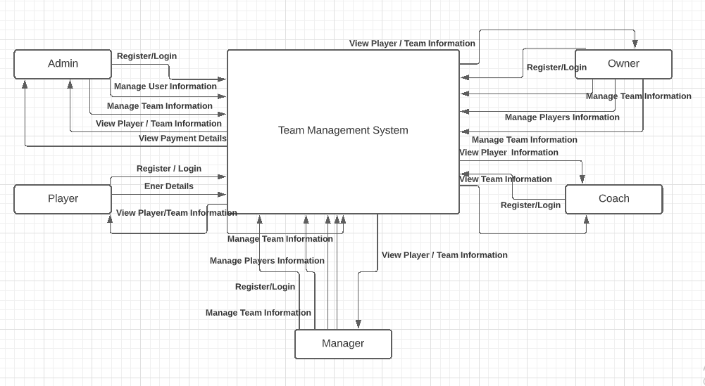

***3.3 Zero Level DFD***

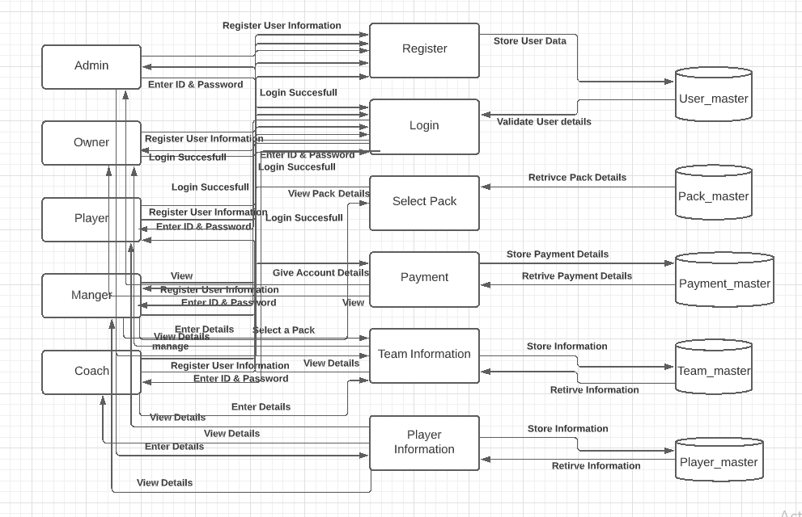

***4.1 Input Form:***

***Register:***

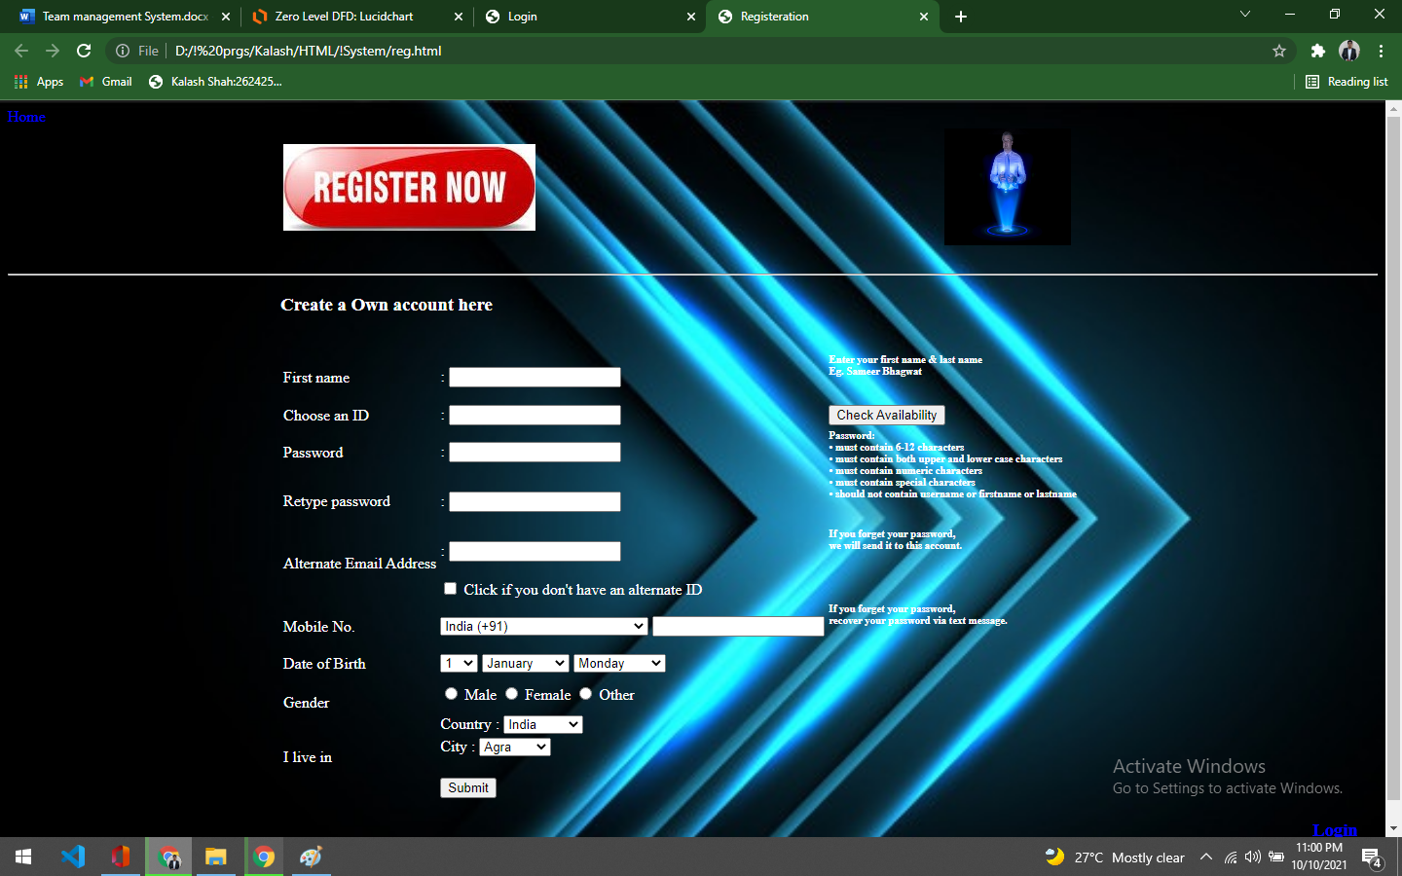

***Login:***

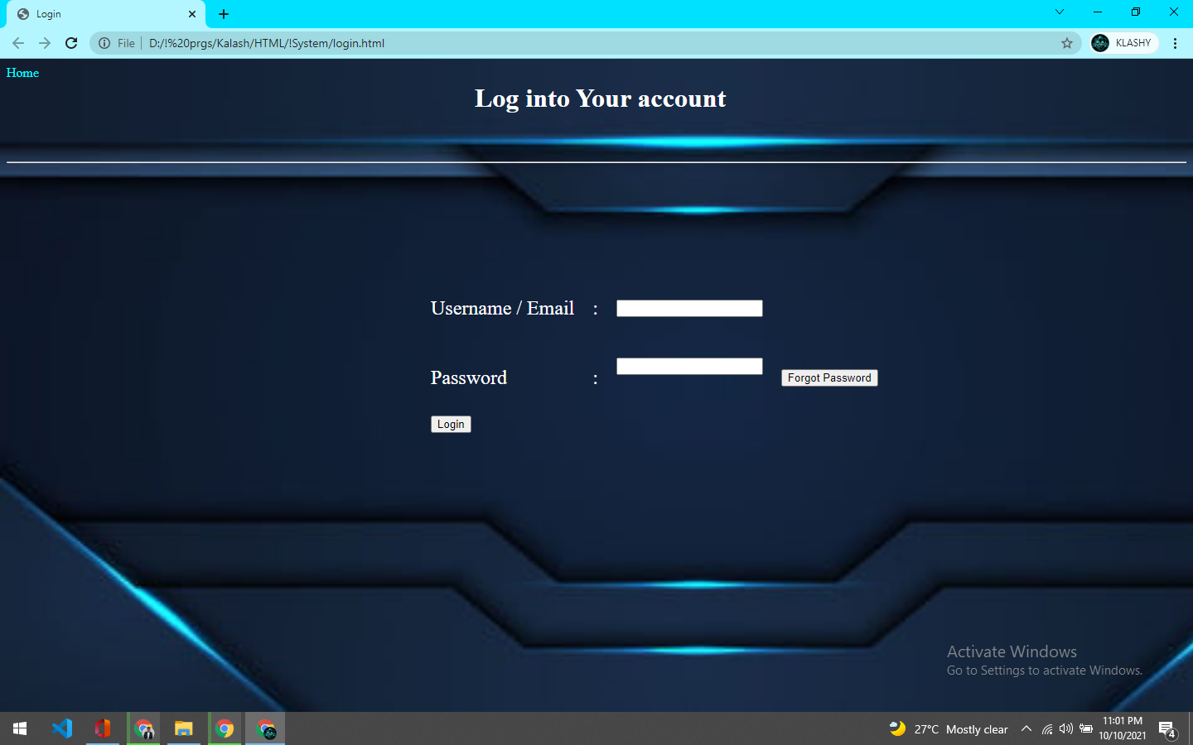

***Payment:***

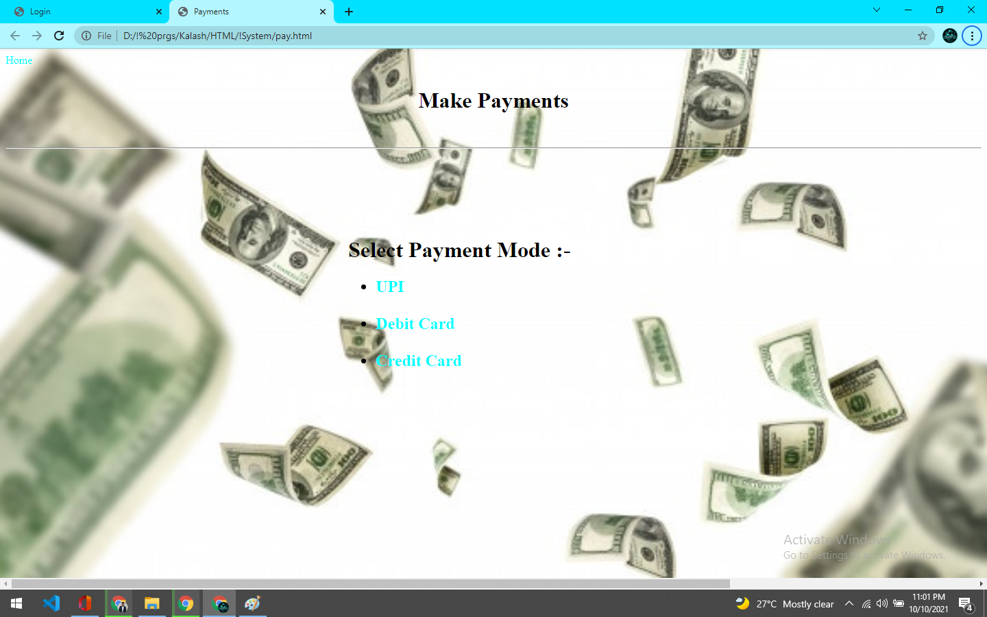

***UPI:***

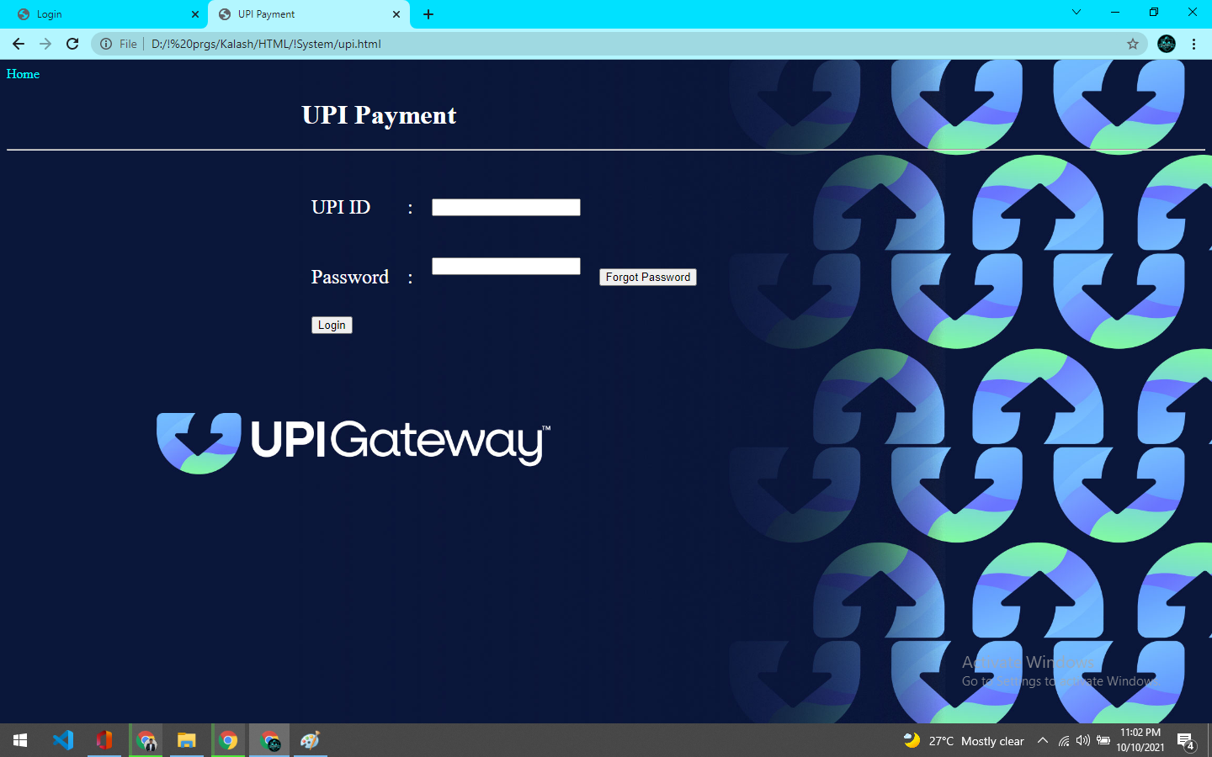

***Credit Card:***

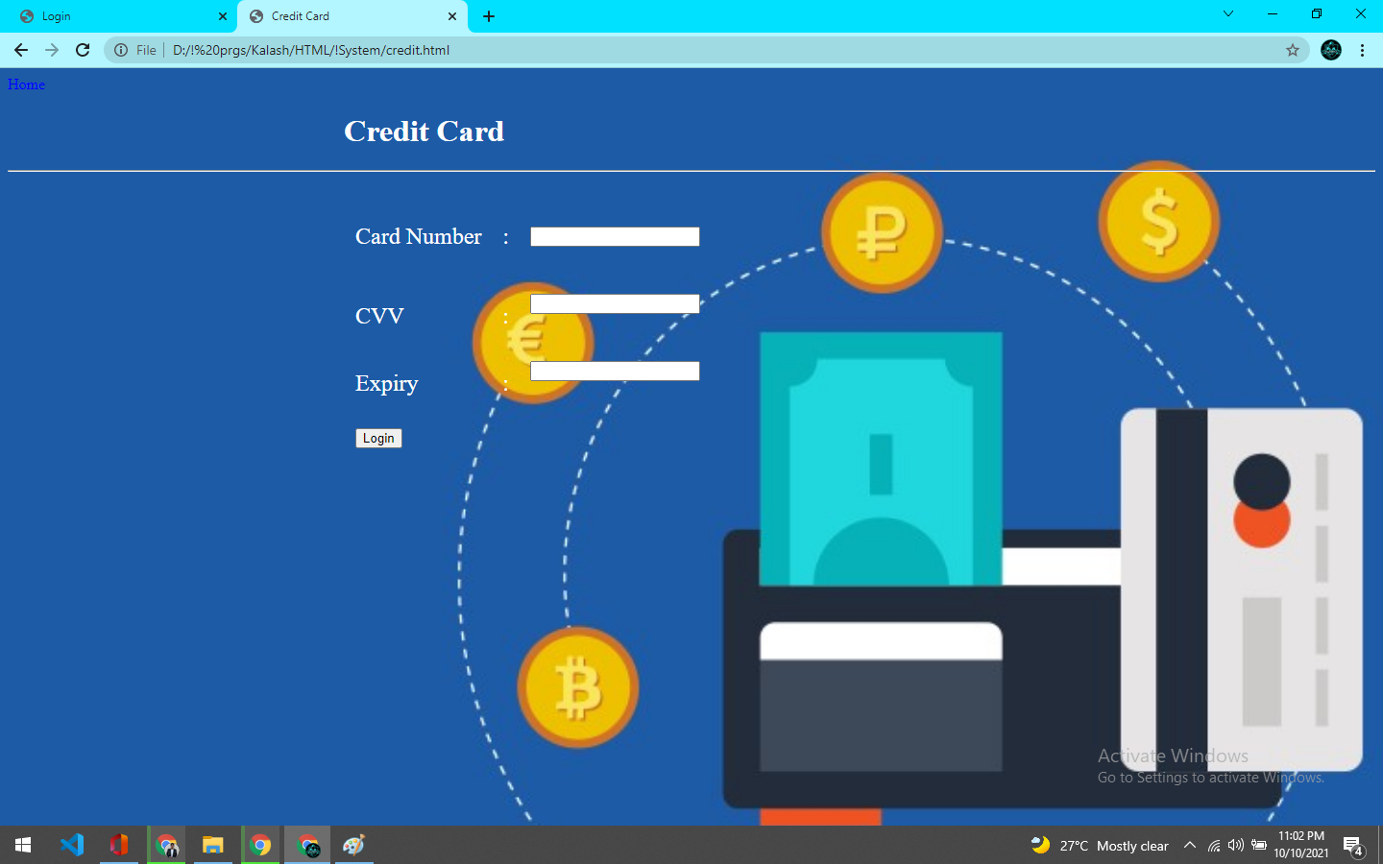

***Debit card:***

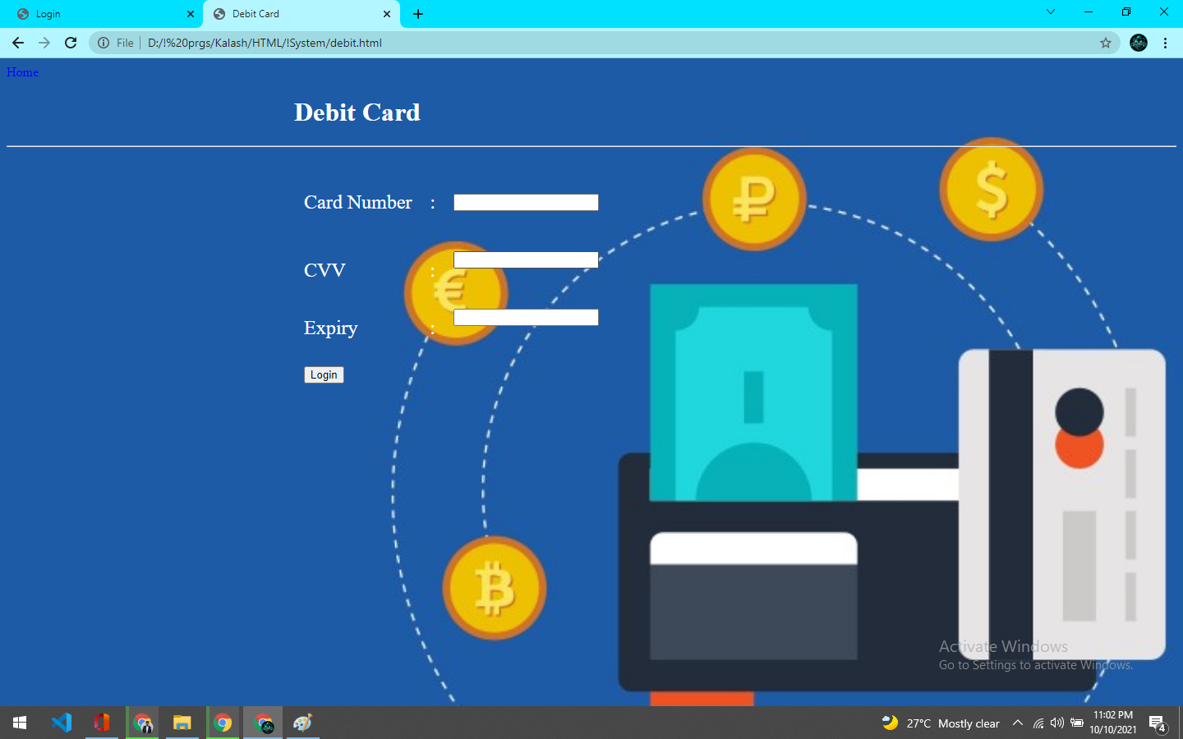

***4.2 Output Form:***

***Payment Receipt:***

